TASK | 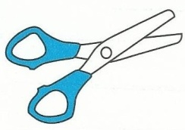  Use | Strips | Conversions  How many cm are there in 3m? | HALF  the distance | TWICE  the length | DOUBLE  49 m | Circle answer  6m equals 6,000cm 6,000mm 600cm | A stick = 5m.  6 sticks together =? | Broken rulers | Show  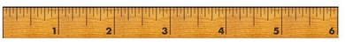  3½cm. | A tree =3m Which is true for its length?  300cm 3,000mm | People chart  10cm – tom  12cm –Jack  ……. | QUARTER  rope = 8m | SCORE  130
- Student A |  |  |  |  |  |  |  |  |  |  |  |  |  | 115
- Student B |  |  |  |  |  |  |  |  |  |  |  |  |  | 110
- Student C |  |  |  |  |  |  |  |  |  |  |  |  |  | 130
 |  |  |  |  |  |  |  |  |  |  |  |  |  | 100
 |  |  |  |  |  |  |  |  |  |  |  |  |  | 110
 |  |  |  |  |  |  |  |  |  |  |  |  |  | 95
 |  |  |  |  |  |  |  |  |  |  |  |  |  | 90
 |  |  |  |  |  |  |  |  |  |  |  |  |  | 90
 |  |  |  |  |  |  |  |  |  |  |  |  |  | 120
 |  |  |  |  |  |  |  |  |  |  |  |  |  | 130
 |  |  |  |  |  |  |  |  |  |  |  |  |  | 60
 |  |  |  |  |  |  |  |  |  |  |  |  |  | 40
 |  |  |  |  |  |  |  |  |  |  |  |  |  | 50
 |  |  |  |  |  |  |  |  |  |  |  |  |  | 80
 |  |  |  |  |  |  |  |  |  |  |  |  |  | 120
 |  |  |  |  |  |  |  |  |  |  |  |  |  | 90
 |  |  |  |  |  |  |  |  |  |  |  |  |  | 115
 |  |  |  |  |  |  |  |  |  |  |  |  |  | 100
 |  |  |  |  |  |  |  |  |  |  |  |  |  | 95
 |  |  |  |  |  |  |  |  |  |  |  |  |  | 70

